1. Develop the project schedule showing dependencies.

Below Website Project schedule was created based on 3 resources Business Analyst, Quality Analyst and Developer. The project is 5 and 11 days long and divided into 4 phases.

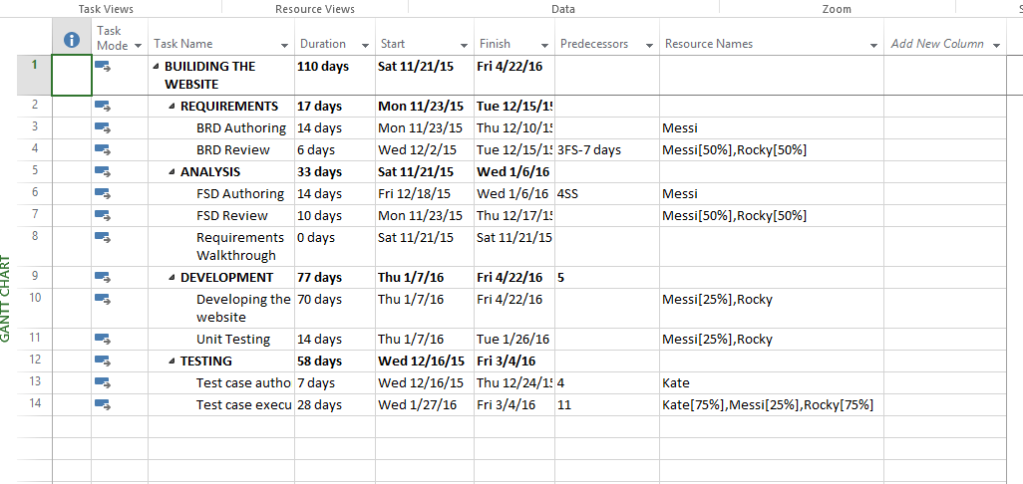

1. Gantt Chartt.
2. Gantt charts illustrate the start and finish dates of the terminal elements and summary elements of a Website building project. Terminal elements and summary elements comprise the structure of the project. Gantt charts also show the [dependency](https://en.wikipedia.org/wiki/Dependency_(project_management)) relationships between activities.

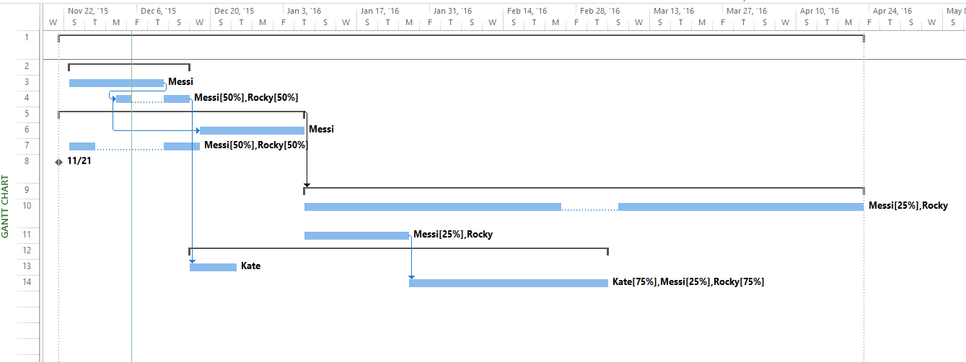

1. Critical Path

The critical path is contains all the activities, which add up to the longest period of project schedule. It may or may not contain slack period.

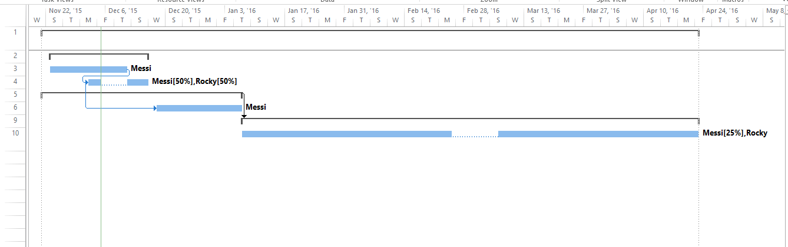

1. Resource leveling before

The process of reallocating the

tasks in such a way so non of the resources are overworked.

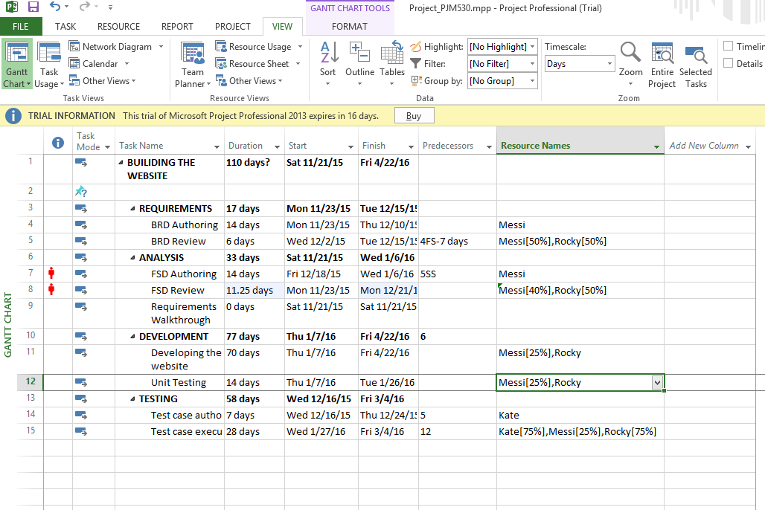

After resource leveling: resources are not over working.

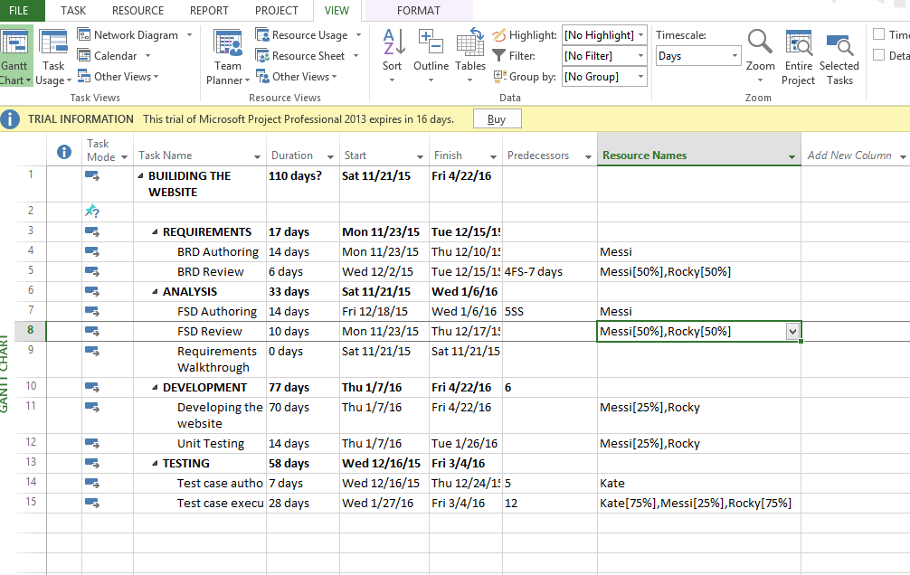

1. Setting project baseline

Setting a baseline so that you can compare it with your up-to-date schedule later in the project. As the project progresses, you may also want to save an interim plan periodically.

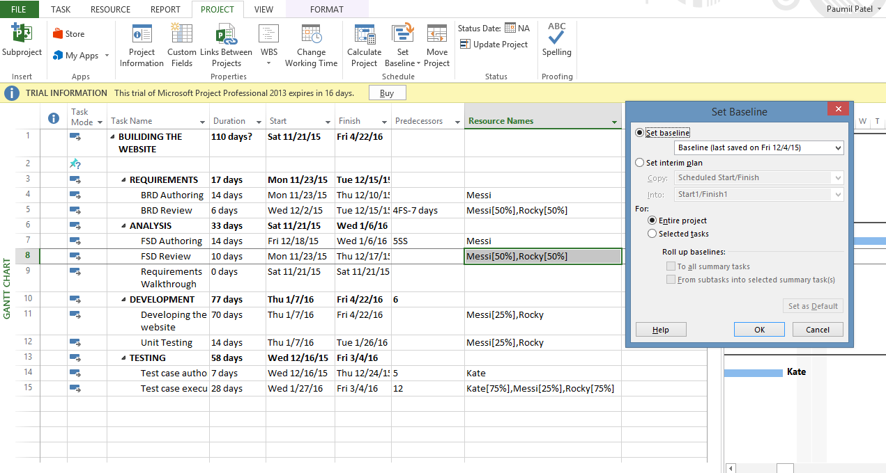

6. Earned value cost indicators.

Earned value (EV): The approved budget for the work actually completed by the specified date.

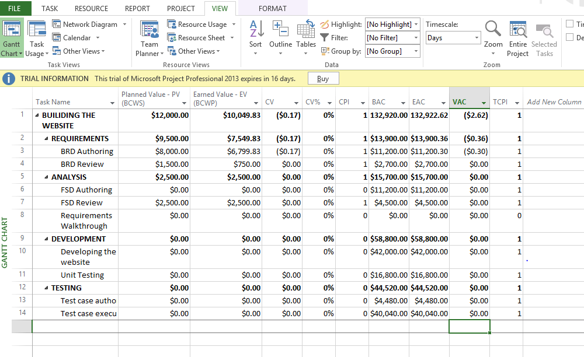

7. Earned value schedule indicators:

Schedule Performance Indicator (SPI) is an index showing the efficiency of the time utilized on the project. SPI can be calculated using the following formula:

SPI = Earned Value (EV) ⁄ Planned Value (PV)

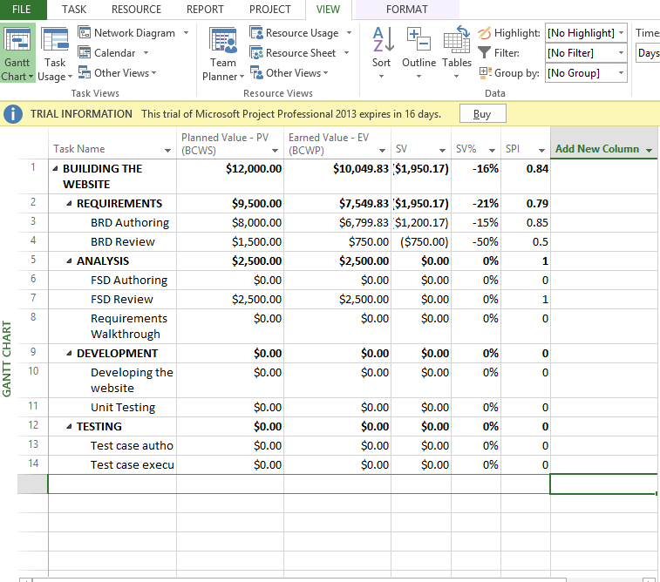

8. Showing slack in the Gantt chart.

A task’s Slack value is the amount of time a task can slip before it has an effect on other tasks or the overall project finish date. There are two basic types of slack: Free Slack and Total Slack.

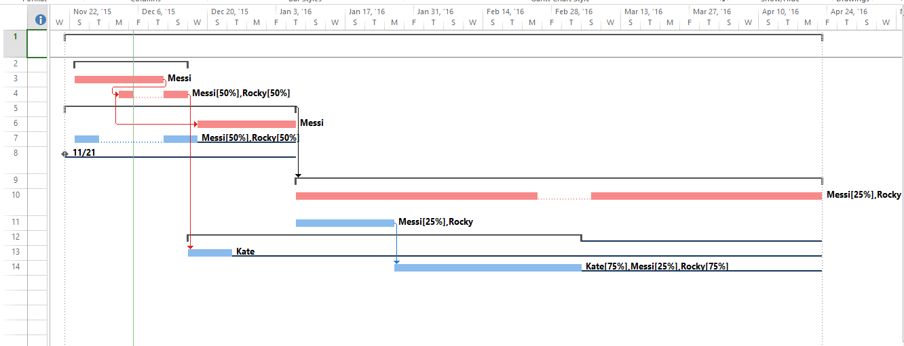

9. Add a milestone.

A milestone is a special event that requires special attention. Milestones can add significant value to project scheduling. The project managers more accurately determine whether or not the project is on schedule.

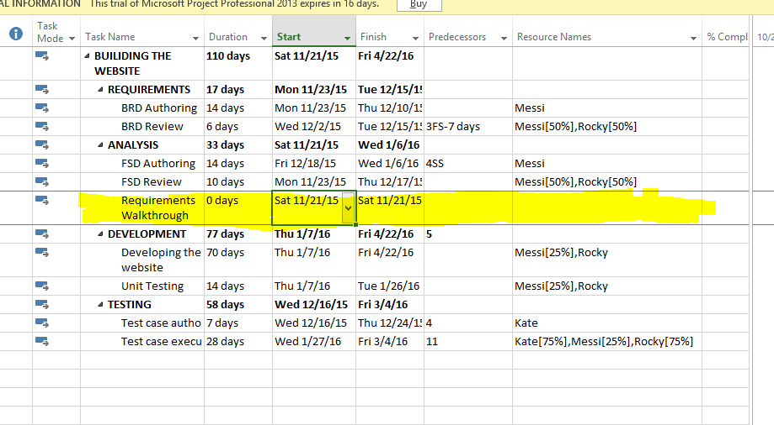

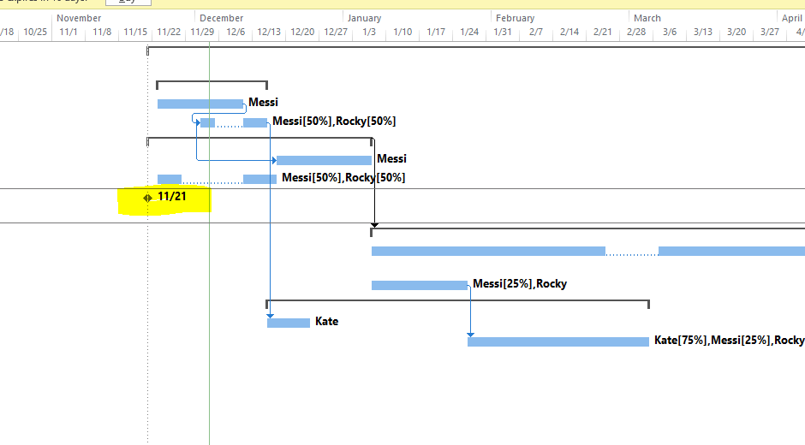

10. Demonstrate a custom report to show resource usage.

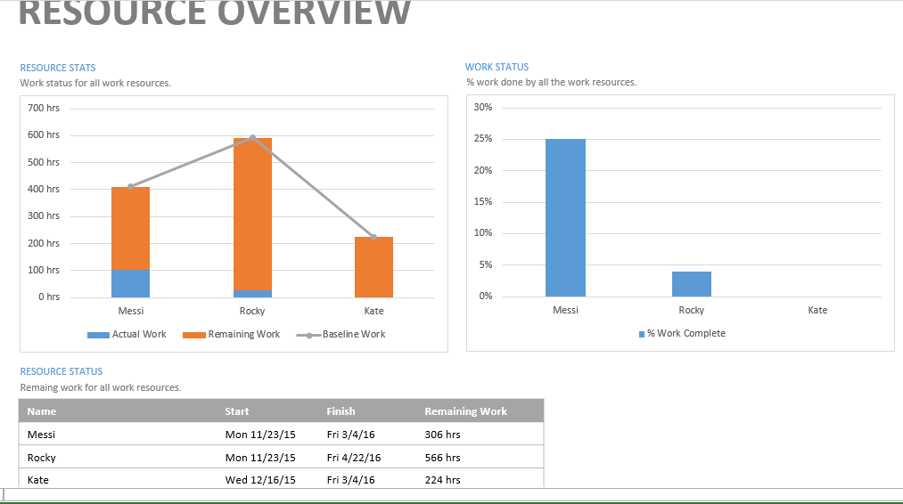

11. Timeline to copy into presentation



12. Calculate a budget.

